Onboarding Template - Scale Army Internal

Hi Victor,
Welcome to Scale Army.

You're joining a team that moves fast, values ownership, and believes in learning by doing.

Over the next few weeks, you'll be diving into your role, meeting the team, and getting familiar with our tools, processes, and expectations.

We know it may feel like a lot at first, that's normal. Everyone goes through it, and everyone figures it out. You're not alone. Ask questions. Take notes. Be proactive.

Cross things off as you go through them in this doc.

We believe in you — let’s get started.

Cheers,
HR Team

General Onboarding

Let’s start with some HR & Admin stuff:
- Sign Contract (Deel and DocuSign)
- Complete Personal Details on Deel
- Add Emergency contact in your Deel account
- Review Stipends Package so you can start with everything you need
- Sign Confidentiality Agreements - HR will send this via email
- Read the Talent Handbook
- Team Org Chart
- Complete Cyber Security training
  - Watch this video
  - Score 20/22 in this Cyber Security Training assessment
Tools Setup
- Email + Google Workspace
  - Calendar:
    - Make EST as your Primary Time Zone. This used to be optional. It is no longer optional.
      - Make sure that you save every single event in EST time, so every time DLS (daylight savings hit, your calendar moves automatically)
    - Your Local time zone as your Secondary Time Zone.
- Install Slack on your computer and on your phone
  - Add your cell phone to your Slack Profile
  - How to use threads
  - How to use hyperlinks
  - Mentions
  - Ask your manager to add you to all the necessary channels:
    - #Scale
      - After you are added here, send a message saying something FUN about yourself
- Use of channel: General information regarding the recruitment process (external): Talent team and AMs report about interview, client's and candidate's progress, feedbacks, DSU related information.
    - #non-work
- Use of channel: Our day to day outside work, you can share fun stuff here. Always with respect.
    - #scale-admin-announcements
- Use of channel: Important announcements from HR or management.
    - #onboarding-won-deals
- Use of channel: candidates who accepted the job offer
    - #offboarding-deals
- ​​Use of channel: talent who have been fired or quit
  - Turn on notifications on your phone and your computer
  - There are A LOT of more channels, so please ask your manager to add you to the ones you’ll need
- Ashby access (recruiting + AM’s + sourcing + HR):
  - Ask Paulina to give you access
- Asana
  - Ask your manager for this access
- HubSpot / CRM (if applicable, most likely just Sales, AMs and CS)
- Chat GPT (if needed, most likely just for Marketing roles)
  - Log into our GPT
    - Hello@scalearmy.com
    - GPTPassword1
- Google Groups: Ask HR to be added to the corresponding Google Groups of your team so you can receive important emails and announcements
  - SA-team@scaelearmy.com
  - Your team’s distro
- Calendar Permissions: In Google Calendar, allow the following people to make changes and manage sharing to your calendar: Alex, Yosele, Laura, Paulina, Dijah and Clara
  - Loom Video with Instructions
- Make sure your events are visible for everyone in SA.
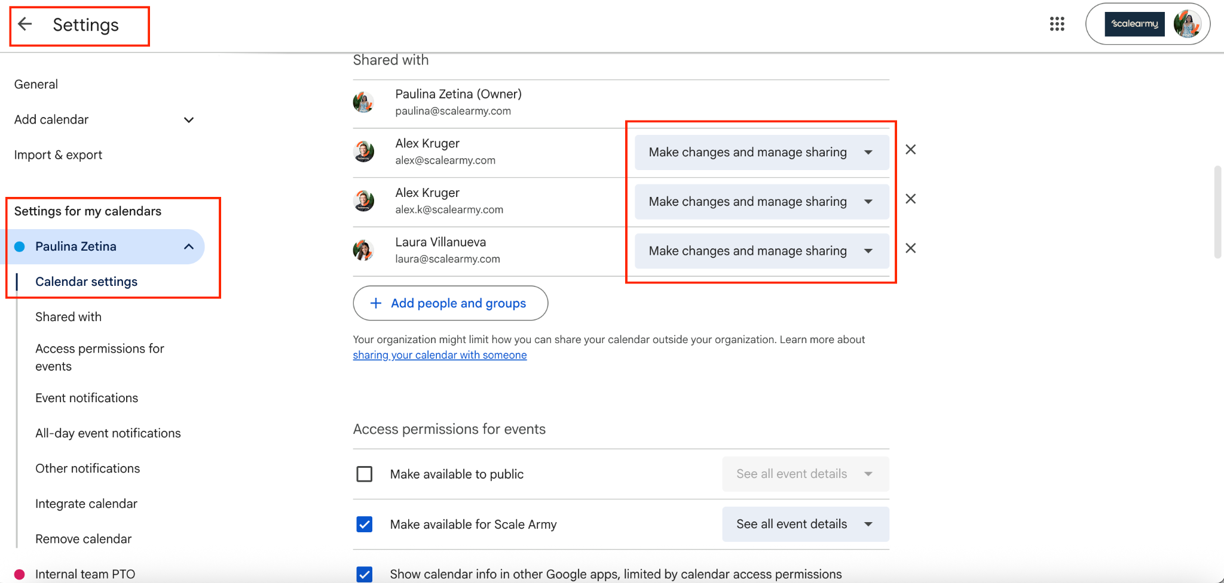
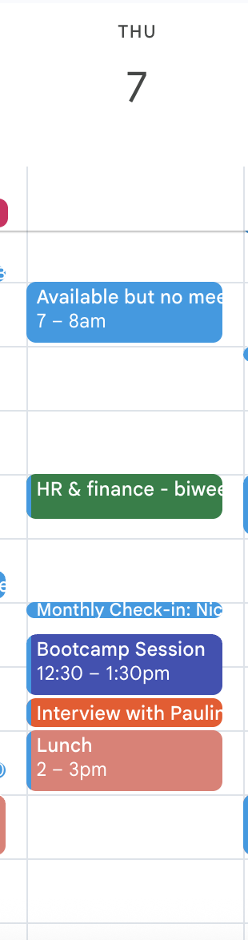
  - Lunch time should be visible in your calendar.

- Learning from Others:
  - Before booking any calls, make sure to check everyone's calendar to make sure they're available, like this:
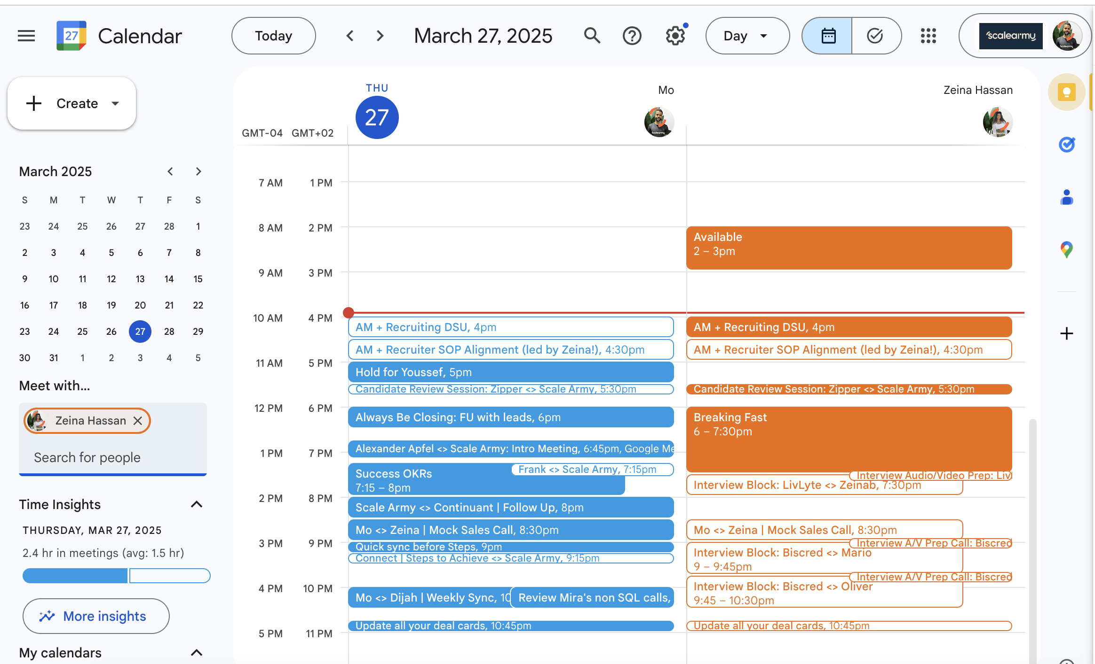
- Grammarly (install on browser)
  - Make sure you grammar is always at a 100% in Slack, emails, meetings and shared documents.
- Update your LinkedIn account with your current role, this helps build trust and credibility, especially when engaging with candidates and external partners.
  - Header Image: Please use this image as your LinkedIn header. It’s beautifully designed to represent our brand!
  - Current Workplace: Update your current workplace to Scale Army.
  - Position Title: Ensure your current role is listed accurately.
- Video Calls background guidelines:
  - Your background is part of your professional presence. Artificial or “fake” backgrounds continually get complaints from clients for looking “cheap and distracting,”especially when lighting or movement causes distortion. A clean and natural environment helps maintain credibility and focus.
  - What’s Recommended:
    - A plain wall (white or neutral color)
    - A SOFT blurred plain wall
    - A simple, tidy background with minimal décor
    - Good lighting facing you (avoid strong backlighting)
    - Camera at eye level
    - A blank wall is completely fine. A blurred blank wall is also great.
  - What to Avoid:
    - Artificial/virtual backgrounds
    - Backgrounds that distort your outline
    - Distracting environments
    - Again. No fake backgrounds ♥️

Branding
- Create your avatar in this canva
  - Here are the background that you can use
- Upload Scale Army Avatar in Slack, Gmail, Ashby and Deel.
- Add your Job Title on the profile section in Slack.
- Set Up Branded Email Signature
  - See Loom Video
- Add Brand Assets in Slack, Gmail, Asana.

Knowledge and Culture
- Read "Scale Army: Internal SOPs" folder
- Review these policies:
  - Time off
  - Stipends
  - OOO Policy
- Scale Army Core Values
- Company Culture Nuances
  - Weekend Share: Every Monday, someone has been nominated to share their weekend. That person gets five minutes. They should come with a presentation of some kind. It doesn't have to be pretty, but it has to be thoughtful.
  - NOTW and SOTW: Slays of the Week. Newbs of the Week. They are very important to us. Ask your manager what they are and how they work, but the TLDR is that throughout the week, you should be keeping track of the amazing things and not-so-amazing things that you and everyone else around you is doing. Then on Friday, you present them in a list. This is a core part of our culture. There is nothing wrong with Newbs. Giving yourself Newbs means you’re self-aware. If you fail to give yourself Newbs, you probably won't be here long because we assume that you aren’t aware of how important it is to grow.. If you’re a manager who isn’t giving out Newbs, your time here will also probably be quite short. One of the largest sins in this company, besides being late without notice, is failing to give yourself Newbs. The people who give themselves Newbs are always the people who end up getting promoted.
  - Friendly Fire: During a meeting, if you get called on for friendly fire, you have to ask someone else in the meeting a question about the content of the meeting.
  - Lateness: People are late. That is totally fine. You can be as late as you need to. What is not fine is being late without notice. Never be late to a meeting unless you tell everyone first. That means one minute late. One minute late is late. If you're going to be one minute late, you must send a message in the Slack channel of the people that are meeting, telling them that you're going to be one minute late before you are late. If you are more than one minute late and didn't send notice, you should give yourself a NOTW, or your manager should give it to you.
  - Meeting Ownership: Every meeting is run by 1 person. If you join a meeting and you're not sure who's running the meeting, you need to say, "Who is running this meeting?" If you can't figure out who is running the meeting, or no one wants to run the meeting, you should cancel the meeting. If the person who is running the meeting is not prepared for the meeting, that person should screen share, write down the goal of the meeting, and start taking notes.
- Things we can and cannot say
  - Make sure you understand everything on Slide 10
- Sheets we live on Google Sheets. This is probably the most important macro-database that you will use. Bookmark it!
- Health Dash Board

Security and Privacy
- Enable 2FA on Email, Slack, Asana:
  - 2FA Setup Video - Slack
  - 2FA Setup - Gmail

Marketing — Senior Paid Media Buyer

Hey Victor,.

Now let’s do the role stuff.

Here’s Why You’re Here

Scale Army is running $50-60k/month in paid spend across Meta and other channels. The results were strong until January. Then they weren't. And now we need to get back to where we were, and then go well beyond it.
You're here because that job requires someone who has actually done this before. Not someone who will figure it out. Someone who already knows what "good" looks like at this level, can diagnose what broke, and can build the infrastructure to scale to $100k/month without the wheels falling off.
Right now, paid acquisition is our primary growth lever. Meta is the core channel, but we're too dependent on it — and that's a problem. Performance has been inconsistent, cost per meeting held is way higher than what it should be and our pipeline is falling short.
This is not a campaign management role. It's not a reporting role. It's not a "check in with the agency on Fridays" role. You are the person who owns paid acquisition outcomes, full stop. That means you're inside the platforms, you're partnering with Sales to close the loop on lead quality, and you're making sure every dollar of spend is connected to pipeline and revenue.
Own it, control it, stabilize it, and then grow it.
But if you do that well, the role grows with you. We're not hiring a campaign manager, we're hiring someone who can eventually own growth. That means being fully accountable for the budget, for the results, and for what comes next. Not just the challenges we have today, but the ones we haven't hit yet.
And that's why you're here.

Your Team
You report directly to Clara (Head of Marketing).

Key stakeholders you’ll work with closely:
- Ali — Marketing Manager, leading CRO, Content and Creative (MKT)
- Rafael — Videomaker (MKT)
- Nico — Design and CRO (MKT)
- Alex — CEO (supports Marketing A LOT)
- Sinead — Content, Lead Magnets, Organic Social for Alex (MKT)
- Annie — Social Media (MKT)
- Seif — Everything HubSpot related
- Mira - Head of Inbound Sales
- Isaac - SDR, helps us daily with process checking and a qualitative view on conversions, needs to be your counterpart in the sales team
- Dijah - Head of Revenue Growth, responsible for the Sales Team, with an overview of numbers and processes

Your Main Tech Stack
- HubSpot — CRM, funnel tracking, Ad Spend
- Ads Manager - Meta, LinkedIn, X, Google
- Looker Studio — Support for tracking

Your 90-Day OKRs

You'll create these and present them to Clara and Alex (for Q2). They should align with your compensation plan.

First Steps
Read this entire document and confirm you understand the role before doing anything else.

Then push Command F, search for “Schedule,” and start booking times on people’s calendars so everything gets done in time.

You can see everyone’s calendar by entering their email on the left side of Google Calendar. On Fridays, most people won’t meet after 2 PM EST but are still responsive on Slack.

PS. Do NOT double-book anyone :D
PPS. Book meetings as early in the week as possible so you have time to put what you learn into action.

Week 1: Learn the Business
In your first week, you’re learning how Scale Army works as a business — the delivery side, the sales side, the client side.

You should end the week by:
- Beginning to understand how we work as a business - and the people behind it
- Auditing our paid media channels (mainly Meta): campaign structure and performance for the last 6 months
- Understanding our budget, goals, and funnel for the next 3-6 months
- Setting the first tests and changes you want to make on Meta to improve performance

Meetings of the Week
(Book as early in the week as possible)

- Schedule a recurring 30-minute check-in with Clara — 2 days a week, EOD for Weeks 1 and 2. Come prepared with questions every single time.

- Schedule 30 minutes with Ali and cover:
  - Structure of his team
  - SOP and processes for CRO tests
  - Current and future goals
  - Current challenges

- Schedule 30 minutes with Diogo (Paid Media Freelancer - since March) and cover:
  - Current Meta structure
  - Past and current campaigns - what worked, what didn't

- Schedule 30 minutes with Isaac and cover:
  - Walk through the pre-sales process
  - What is and how do we use Chit chat, Trixie, and email sequences
  - How he used to collaborate with Luan to make sure we're on top of lead quality, meeting no-shows, campaign successes, etc

- Schedule 30 minutes with Laura and have her walk you through:
  - How the delivery team is structured
  - How we make margins on Scale Army talent
  - How the recruiting pods are organized and how they operate

- Schedule 30 minutes with Mira and cover:
  - What she considers our best clients and why
  - TOF meeting: reporting and how we can improve it

- Schedule 15 minutes with Alia and have her explain:
  - How we set OKRs here
  - What are good OKRs and bad OKRs

Week 2: Owning Paid Media (Meta)
You should end the week by:
- Having a clear diagnosis of our challenges and next steps in Paid Media (Meta)
- Setting an plan for new creatives and optimizations that we need to reach our April goals

Meetings of the Week
(Book as early in the week as possible)

- Continue your 30-minute Clara check-ins — 2 days a week EOD. This is the last week at this cadence, so make them count.

- Schedule 30 minutes with Alex and cover:
  - Understand his marketing background
  - Ask him about his plans for Scale Army Placements and Upcraft
  - His impressions on what works and what doesn't for marketing (and Paid Media)

- Schedule 15 minutes with Sinead and cover:
  - Learn about our brands (SA & SAC)
  - Understand how we take care of organic content (and how we want to use paid to improve it)
  - Creative SOP

- Schedule 15 minutes with Rafael and cover:
  - History of our video (creative) creation for Paid Media, current challenges and plans
  - SOPs

- Schedule 15 minutes with Nico and cover:
  - His work with LP creation and CRO
  - His work with design

- Schedule 30 minutes with Dijah and cover:
  - MQL vs SQL
  - Team structure
  - What is Upcraft, and what are we currently doing to kick it off

- Schedule 15 minutes with Elena and:
  - Have her walk you through her background and what her previous role covered
  - Understand how she's leading outbound and what help she might need
  - Ask her about her experience with LinkedIn Ads

- Schedule 30 minutes with Clara and cover:
  - How the marketing team is organized — who does what, what everyone’s strengths are
  - What channels does she think make the most sense for selling and promoting Agents in May
  - What she’s excited about for the product and what she’d want to lead with

- Schedule 15 minutes with Joe and cover:
  - Understand the full sales process through engagement letters
  - Learn why clients love us and the top-requested searches

Your goal after 30 days
By the end of your first 30 days, you should:
- Fully understand how the marketing and sales department runs — how leads move from ad click to meeting held to closed deal, who owns what, where the handoffs are, and where the friction lives.
- Stabilize Meta performance and prepare to scale — audit what changed, identify what broke, and have campaigns running clean. Stable. Cost per meeting held trending in the right direction, attribution trusted, no unexplained bleed.
- Audit our current agencies and freelancers — evaluate every external resource we're using for paid media. For each one: what are we getting, what are we paying, and is that a good trade? Come back with a clear recommendation on what to keep, what to cut, and what to bring in-house.
- Build and present a channel diversification plan — Meta cannot be our only engine. We need a clear-eyed view of what diversification actually looks like for us: which channels are worth testing (Google, LinkedIn, CTV, X), how much investment each requires, what realistic results look like in 90 days vs. 6 months, and what we'd need to change operationally to make it work.
Your first 30 days are about getting the house in order and showing us how you think. The strategy work you present at day 30 should make it obvious that you understand our business, not just paid media in general.

Key Milestones Summary

Day | Milestone
Day 7 | Send OKRs to Clara
Day 14
Day 21
Day 30
Day 45
Day 60
Day 75
Day 90

Congrats on making it this far :D

You have full autonomy over how you meet your OKRs. Alex will work with you every week to course-correct, but the strategy and execution are yours to own.

